Week 2- Software Architecture

Author: Adrian Pan, Eric Vuong

Date: February 27th, 2015

Table of Contents

Class Hierarchy 1

Timeline for Development and Testing 2

# Class Hierarchy

**Universal Modeling Language:**

Note: obstacle avoidance is part of the Navigation class

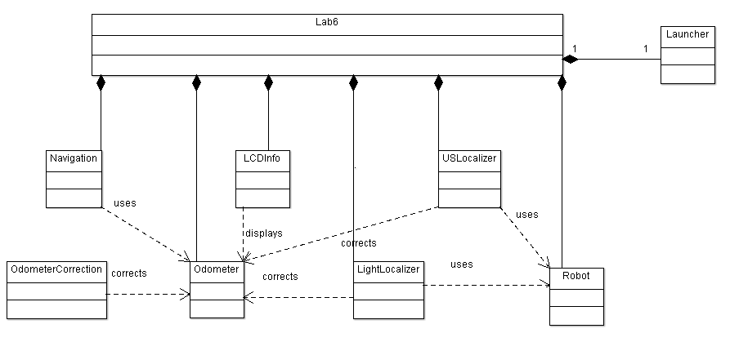

**States Table:**

# Timeline for Development and Test

Gathering all the codes from Lab 5 – March 4th

Integrate all the codes together – March 6th – 7th

Tune essential (turning off obstacle avoidance and localization) codes – March 8th – 9th

Odometer Calibration– March 8th

* Purpose: find the necessary constants for the odometer experimentally
* Design of the experiment: track the location of the robot by going forward, backward and doing a squared track, and adjust the odometer’s constants until the display shows the correct location

Launcher Calibration – March 9th

* Purpose: find distance as a function of the angle of the rail and the speed of the bat
* Design of the experiment: adjust the angle of the rail manually and see how far the ball will travel. Do this repeatedly and collect data. Through mathematically means, determine the equation

LightLocalizer Testing - March 10th

* Purpose: Investigate the performance of USLocalizer
* Design of the test: start the NXT at different angles and record the error (the calculated 0 degrees – absolute 0 degrees). Make adjustments if necessary

Navigation (without avoidance) Testing – March 11th

* Purpose: Investigate the performance of navigation.
* Design of the test: make the robot travel different distances with the direction fixed and make the robot travel in different directions with the distance fixed. Record the error. Make adjustments if necessary

USLocalizer Implementation/Experimentation – March 15th

* Purpose: Implement a working algorithm for the robot to know its position by using ultrasonic sensor
* Design of the experiment: record the distances reported by the ultrasonic sensor, analyze the data and determine if any filter is needed. Repeat this process until local minimum can be found

USLocalizer Testing- March 16th

* Purpose: Investigate the performance of USLocalizer.
* Design of the test: start the NXT at different angles and record the error (the calculate orientation vs. actual orientation).

Navigation (Avoidance) Implementation/Experimentation – March 21st

* Purpose: Investigate the performance of avoidance.
* Design of the test: place obstacles of different shapes in the robot’s traveling direction and record the result (avoided/ not avoided).